**A PROJECT REPORT ON**

**ONLINE FOOD SERVICES SYSTEM**

**Submitted By**

**Thanki Chirag Jitendrakumar**

**(Enroll No.: R24014201004963210031)**

**Guided By: Dr. Zalak Thakrar**

**In fulfillment for the award of the degree**

**of**

**Master of Science in Information Technology**

**In**

**Computer Department**

**Shri V. J. Modha College of I.T, Porbandar**

**Bhakt Kavi Narsinh Mehta University, Junagadh**

**October 2024**



**Acknowledgement**

• I am sincerely grateful to all those who contributed towards the completion of this **Online Food Services System** project developed using PHP programming, MySQL database, HTML, CSS, JS and framework like Bootstrap. This project would not have been possible without the guidance and support of many individuals.

• First and foremost, I would like to thank **Dr. Zalak Thakrar** for his invaluable guidance, insightful feedback, and constant encouragement throughout the course of this project. Their expertise and suggestions were instrumental in the successful implementation of this system.

• I would also like to express my gratitude to my peers and fellow classmates who provided constructive feedback and motivation during challenging times. Their input was vital in refining the project's features and improving its functionality.

• It is my great pleasure to represent my project as one web application titled “Online Food Services System” and which done in semester-1 of MSc I.T., affiliated to BKNMU (Bhakta Kavi Narsinh Mehta University).

• Additionally, I am thankful for the availability of various online resources and forums that offered technical insights and solutions to the issues I encountered during the development process.

• Lastly, I would like to extend my appreciation to my family for their unwavering support and understanding while I dedicated time to this project. Their encouragement helped me stay focused and motivated.

**PREFACE**

This desktop application provides facilities like:

* + Login to user
  + Login to Admin
  + Manage food dishes
  + Manage food order
  + Manage restaurants
  + Update order
  + Inform user
* This system is made using MySQL Database for storing data and HTML, CSS, JS, for front-end part (client-side) and PHP for back-end (server-side).
* I used XAMPP for server access.
* This system has only access right to Admin.

**INDEX**

|  |  |  |
| --- | --- | --- |
| **Sr. No.** | **Topic Name** | **Page No.** |
| **Chapter – 1** | INTRODUCTION   * 1. Purpose   2. Scope   3. Technology and Literature Review | 5 |
|  |
| **Chapter – 2** | SYSTEM ANALYSIS   * 1. Problem Definition   2. Process Model   3. Grant Chart | 9 |
|  |
| **Chapter – 3** | SYSTEM DIRGRAM   * 1. Data Flow Diagram   2. E-R Diagram   3. Use Case Diagram | 13 |
| **Chapter – 4** | DATA DICTIONARY  4.1 Data Dictionary | 17 |
| **Chapter – 5** | INPUT AND OUTPUT DESIGN  5.1 Admin Layout | 20 |
| **Chapter – 6** | IMITATIONS AND FUTURE ENHANCEMENT   * 1. Limitations   2. Future Enhancement | 51 |
|  |
| **Chapter – 7** | CONCLUSION   * 1. Conclusion   2. Advantages | 56 |
|  |
| **Chapter – 8** | BIBILIOGRAPHY  8.1 Bibliography | 58 |
| **Chapter – 9** | REFERENCES  9.1 Reference | 60 |

Chapter -1 INTRODUCTION

1.1 Purpose

1.2 Scope

1.3 Technology and Literature Review

## 1.1 Purpose

The Online Food Services website is a comprehensive, Online Food Services-focused platform designed to empower users by offering detailed information about a wide variety of food items and their Online Food Services content. Whether users are looking to understand the Online Food Services value of specific ingredients or seeking guidance on how to achieve their dietary goals, Online Food Services provides a one-stop solution. The platform is tailored to meet the needs of individuals who are on personalized journeys, such as weight loss, weight gain, or maintaining a balanced diet. It allows users to create custom diet plans by inputting their goals and preferences, ensuring that their meals are not only Online Food Services but aligned with their health objectives.

One of the standout features of the Online Food Services website is its user-friendly interface, which ensures that users of all ages and technological skill levels can easily navigate the platform. The personalized diet plan feature gives users the flexibility to tailor their daily meals to match their caloric and Online Food Service needs. Whether they want to reduce fat intake, boost protein consumption, or increase their intake of vitamins and minerals, the platform helps them design a meal plan that fits their unique health goals.

## 1.2 Scope

To enhance the personalized experience, Online Food Services offers a secure and efficient login and sign-up feature, enabling users to create accounts that store their dietary preferences, past purchases, and personalized meal plans. Registered users also gain access to exclusive content such as Online Food Services tips, recipes, and personalized recommendations that help them stay on track with their health goals. This feature fosters a sense of community, as users can also share their favorite meals and tips with others.

The backend and frontend of Online Food Services are well-structured, ensuring a smooth and intuitive experience across all devices. The backend is built to handle everything from user data management to secure transactions, ensuring that personal information and payment details are protected. Meanwhile, the frontend is designed with a modern and clean aesthetic, providing a visually appealing and easy-to-navigate layout that keeps users engaged and motivated in their health journey.

In summary, Online Food Services serves as a comprehensive platform that not only educates users on Online Food Services content but also provides tools, they need to take control of their health. With features that range from personalized diet planning to a full e-commerce system for purchasing Online Food Services food, Online Food Services aims to make healthy living accessible and achievable for everyone.

## 1.3 Technology and Literature Review

* **FRONT-END**
  + Front-end development (also known as Client-side development) is the process of using HTML, CSS, and JavaScript to create a graphical user interface for a website or web application so that users can interact with them.
  + By using graphical methods, the complex backend portion is represented in an understandable way for the end-user.
  + Languages used for the front end are HTML, CSS, and JavaScript while those used for the back end include Java, Ruby, Python, and .Net.
* **BACK-END**
  + Back-end development (Also known as Server-side development) is the process of server-side languages like PHP, Python, Java, Ruby, .Net, etc.
  + MySQL Storage Backend. The MySQL storage backend is used to persist Vault's data in a MySQL server or cluster.
  + High Availability – the MySQL storage backend supports high availability. Note that due to the way MySQL locking functions work they are lost if a connection dies.

Chapter -2 SYSTEM ANALYSIS

2.1 Problem Definition

2.2 Process Model

2.3 Grant Chart

2.1 Problem Definition

* A food service website is a platform that connects customers with restaurants, caterers, or food delivery services. The core problem it solves is making food ordering and dining experiences more convenient for users. However, certain challenges arise in the process of building and maintaining a food service website.

2.2 Process Model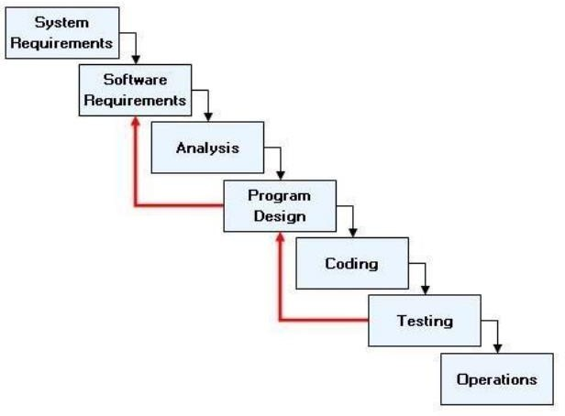

#### Advantages of Iterative Waterfall Model

* Simple and Easy to Understand and Each Phase has well Defined Input and Output.
* It Work well for Smaller Project Where Requirement Are Clear And very well understood.
* It Divide complex task into more manageable works.

2.3 Grant Chart

|  |  |
| --- | --- |
| **Guide Name: Dr. Zalak Thakrar** | |
| **Date** | **Task** |
| 03-8-2024 | Project Title |
| 10-08-2024 | Information Gathering |
| 17-08-2024 | Table Structure |
| 24-08-2024 | Diagram |
| 31-08-2024 | Form Design |
| 07-09-2024 | Project Validation |
| 14-09-2024 | Half Coding |
| 21-09-2024 | Full Coding |
| 28-09-2024 | Document |
| 05-10-2024 | Project Certificate Issue |
| 12-10-2024 | Final submission with Soft & Hard Copy |

Chapter -3 SYSTEM DIAGRAM

3.1 Data Flow Diagram

3.2 E-R Diagram

3.3 Use-Case Diagram

3.1 Data Flow Diagram

* **3.1.1 DFD-Level-0**

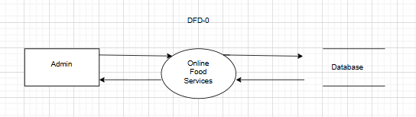

* **3.1.1 DFD-Level-0**

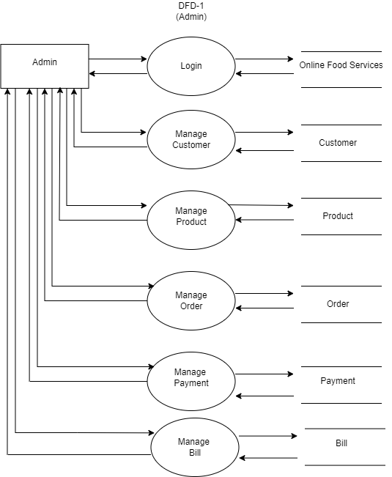

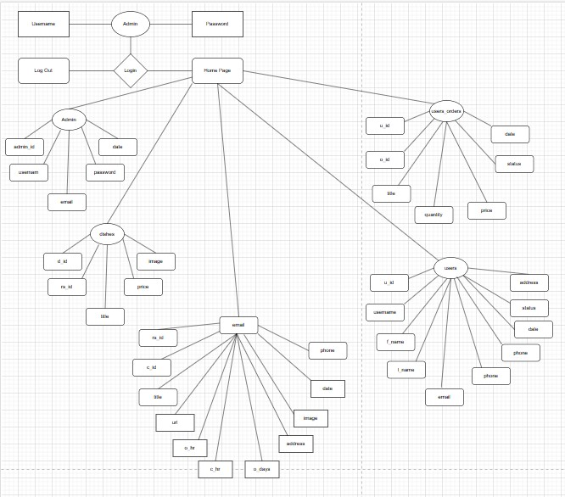3.2 E-R (Entity-Relationship) Diagram

3.2 Use-Case Diagram

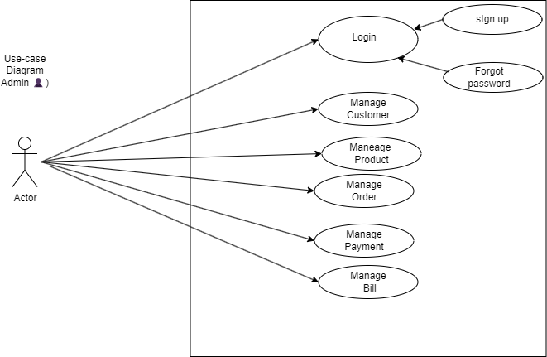

Chapter - 4 DATA DICTIONARY

4.1 Data Dictionary

4.1 Data Dictionary

**Tables:**

* Table-1: admin
* Table-2: dishes
* Table-3: restaurant
* Table-4: users
* Table-5: users_orders

**Table-1: admin**

|  |  |  |
| --- | --- | --- |
| **Field** | **Data Type** | **Description** |
| adm_id | Int | It represents admin id |
| username | varchar | It represents username |
| password | varchar | It represents password |
| email | Varchar | It represents email |

**Table-2: dishes**

|  |  |  |
| --- | --- | --- |
| **Field** | **Data Type** | **Description** |
| d_id | Int | It represents dish id |
| rs_id | Int | It represents restaurant id |
| title | varchar | It represents restaurant title |
| address | Varchar | It represents restaurant address |
| img | varchar | It represents restaurant image |

**Table-3: restaurant**

|  |  |  |
| --- | --- | --- |
| **Field** | **Data Type** | **Description** |
| rs_id | Int | It represents restaurant id |
| email | Int | It represents restaurant email |
| title | varchar | It represents restaurant title |
| address | Varchar | It represents restaurant address |
| img | varchar | It represents restaurant image |
| Phone | Varchar | It represents restaurant phone |

**Table-4: users**

|  |  |  |
| --- | --- | --- |
| **Field** | **Data Type** | **Description** |
| u_id | Int | It represents user id |
| username | Int | It represents username |
| f_name | varchar | It represents user’s first name |
| l_name | Varchar | It represents user’s last name |
| email | varchar | It represents user’s email |
| Phone | Varchar | It represents user’s phone |
| password | varchar | It represents user’s password |

**Table-5: users_order**

|  |  |  |
| --- | --- | --- |
| **Field** | **Data Type** | **Description** |
| o_id | Int | It represents order id |
| u_id | Int | It represents user id |
| title | Int | It represents title |
| quantity | int | It represents order quantity |
| price | decimal | It represents order price |
| status | varchar | It represents order status |
| date | datetime | It represents order date |

Chapter - 5 INPUT AND OUTPUT DESIGN

5.1 Admin Layout

5.2 User Layout

5.1 Admin Layout

Admin Login Page

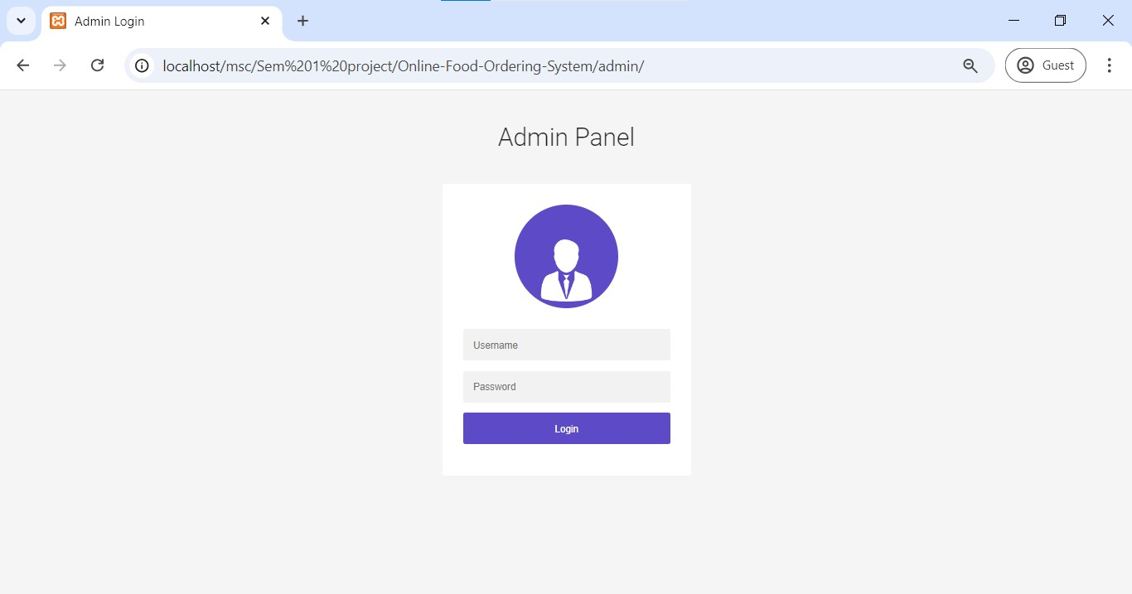

**Description:**

Above figure shows the admin login page where admin can login through username and password. No one can access this page without proper id and password.

<!--  Author Name: Chirag Thanki

                        GigHub Link: https://github.com/chigs-thanky

                        Contact: +91-9638798285

                        Email: chiragthanki12@gmail.com-->

<!DOCTYPE html>

<html lang="en">

<?php

include("../connection/connect.php");

error_reporting(0);

session_start();

if (isset($_POST['submit'])) {

    $username = $_POST['username'];

    $password = $_POST['password'];

    if (!empty($_POST["submit"])) {

        $loginquery = "SELECT * FROM admin WHERE username='$username' && password='" . ($password) . "'";

        $result = mysqli_query($db, $loginquery);

        $row = mysqli_fetch_array($result);

        if (is_array($row)) {

            $_SESSION["adm_id"] = $row['adm_id'];

            header("refresh:1;url=dashboard.php");

        } else {

            echo "<script>alert('Invalid Username or Password!');</script>";

        }

    }

}

?>

<head>

    <meta charset="UTF-8">

    <title>Admin Login</title>

    <link rel="stylesheet" href="https://cdnjs.cloudflare.com/ajax/libs/meyer-reset/2.0/reset.min.css">

    <link rel='stylesheet prefetch' href='https://fonts.googleapis.com/css?family=Roboto:400,100,300,500,700,900'>

    <link rel='stylesheet prefetch' href='https://fonts.googleapis.com/css?family=Montserrat:400,700'>

    <link rel='stylesheet prefetch' href='https://maxcdn.bootstrapcdn.com/font-awesome/4.3.0/css/font-awesome.min.css'>

    <link rel="stylesheet" href="css/login.css">

</head>

<body>

    <div class="container">

        <div class="info">

            <h1>Admin Panel </h1>

        </div>

    </div>

    <div class="form">

        <div class="thumbnail"><img src="images/manager.png" /></div>

        <span style="color:red;"><?php echo $message; ?></span>

        <span style="color:green;"><?php echo $success; ?></span>

        <form class="login-form" action="index.php" method="post">

            <input type="text" placeholder="Username" name="username" />

            <input type="password" placeholder="Password" name="password" />

            <input type="submit" name="submit" value="Login" />

        </form>

    </div>

    <script src='http://cdnjs.cloudflare.com/ajax/libs/jquery/2.1.3/jquery.min.js'></script>

    <script src='js/index.js'></script>

</body>

</html>

Admin Dashboard

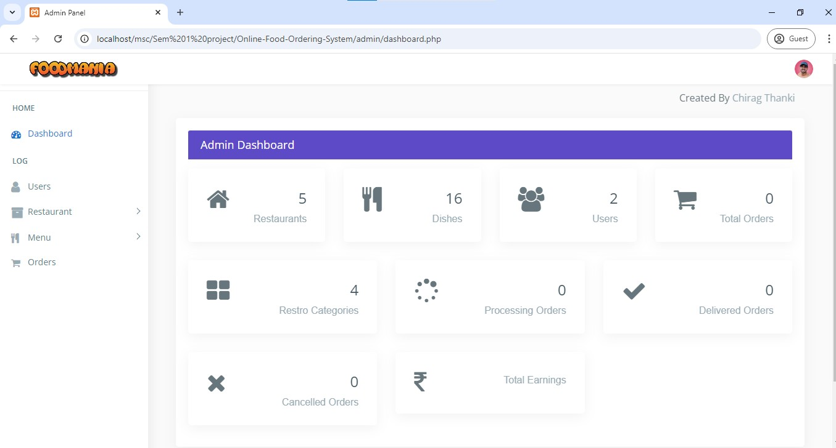

**Description:**

Above figure shows the admin dashboard page after the admin has logged successfully and he can manage different pages thorough admin credentials.

<!DOCTYPE html>

<html lang="en">

<?php

include("../connection/connect.php");

error_reporting(0);

session_start();

if (empty($_SESSION["adm_id"])) {

    header('location:index.php');

} else {

    ?>

    <head>

        <meta charset="utf-8">

        <meta http-equiv="X-UA-Compatible" content="IE=edge">

        <meta name="viewport" content="width=device-width, initial-scale=1">

        <meta name="description" content="">

        <meta name="author" content="">

        <title>Admin Panel</title>

        <link href="css/lib/bootstrap/bootstrap.min.css" rel="stylesheet">

        <link href="css/helper.css" rel="stylesheet">

        <link href="css/style.css" rel="stylesheet">

    </head>

    <body class="fix-header">

        <div class="preloader">

            <svg class="circular" viewBox="25 25 50 50">

                <circle class="path" cx="50" cy="50" r="20" fill="none" stroke-width="2" stroke-miterlimit="10" />

            </svg>

        </div>

        <div id="main-wrapper">

            <div class="header">

                <nav class="navbar top-navbar navbar-expand-md navbar-light">

                    <div class="navbar-header">

                        <a class="navbar-brand" href="dashboard.php">

                            <span><img src="../images/food-mania-logo.png" alt="homepage" class="dark-logo" /></span>

                        </a>

                    </div>

                    <div class="navbar-collapse">

                        <ul class="navbar-nav mr-auto mt-md-0">

                        </ul>

                        <li class="nav-item dropdown">

                            <a class="nav-link dropdown-toggle text-muted  " href="#" data-toggle="dropdown"

                                aria-haspopup="true" aria-expanded="false"><img src="images/bookingSystem/user_icon.jpg"

                                    alt="user" class="profile-pic" /></a>

                            <div class="dropdown-menu dropdown-menu-right animated zoomIn">

                                <ul class="dropdown-user">

                                    <li><a href="logout.php"><i class="fa fa-power-off"></i> Logout</a></li>

                                </ul>

                            </div>

                        </li>

                        </ul>

                    </div>

                </nav>

            </div>

            <div class="left-sidebar">

                <div class="scroll-sidebar">

                    <nav class="sidebar-nav">

                        <ul id="sidebarnav">

                            <li class="nav-devider"></li>

                            <li class="nav-label">Home</li>

                            <li> <a href="dashboard.php"><i class="fa fa-tachometer"></i><span>Dashboard</span></a>

                            </li>

                            <li class="nav-label">Log</li>

                            <li> <a href="all_users.php"> <span><i

                                            class="fa fa-user f-s-20 "></i></span><span>Users</span></a></li>

                            <li> <a class="has-arrow  " href="#" aria-expanded="false"><i

                                        class="fa fa-archive f-s-20 color-warning"></i><span

                                        class="hide-menu">Restaurant</span></a>

                                <ul aria-expanded="false" class="collapse">

                                    <li><a href="all_restaurant.php">All Restaurant</a></li>

                                    <li><a href="add_category.php">Add Category</a></li>

                                    <li><a href="add_restaurant.php">Add Restaurant</a></li>

                                </ul>

                            </li>

                            <li> <a class="has-arrow  " href="#" aria-expanded="false"><i class="fa fa-cutlery"

                                        aria-hidden="true"></i><span class="hide-menu">Menu</span></a>

                                <ul aria-expanded="false" class="collapse">

                                    <li><a href="all_menu.php">All Menues</a></li>

                                    <li><a href="add_menu.php">Add Menu</a></li>

                                </ul>

                            </li>

                            <li> <a href="all_orders.php"><i class="fa fa-shopping-cart"

                                        aria-hidden="true"></i><span>Orders</span></a></li>

                        </ul>

                    </nav>

                </div>

            </div>

            <div class="page-wrapper">

                <div style="padding-top: 10px;">

                    <marquee onMouseOver="this.stop()" onMouseOut="this.start()">Created By <a

                            href="https://chigs-thanky.github.io/Chirag-J-Thanki-Portfolio/">Chirag Thanki</a></marquee>

                </div>

                <div class="container-fluid">

                    <div class="col-lg-12">

                        <div class="card card-outline-primary">

                            <div class="card-header">

                                <h4 class="m-b-0 text-white">Admin Dashboard</h4>

                            </div>

                            <div class="row">

                                <div class="col-md-3">

                                    <div class="card p-30">

                                        <div class="media">

                                            <div class="media-left meida media-middle">

                                                <span><i class="fa fa-home f-s-40 "></i></span>

                                            </div>

                                            <div class="media-body media-text-right">

                                                <h2><?php $sql = "select * from restaurant";

                                                $result = mysqli_query($db, $sql);

                                                $rws = mysqli_num_rows($result);

                                                echo $rws; ?></h2>

                                                <p class="m-b-0">Restaurants</p>

                                            </div>

                                        </div>

                                    </div>

                                </div>

                                <div class="col-md-3">

                                    <div class="card p-30">

                                        <div class="media">

                                            <div class="media-left meida media-middle">

                                                <span><i class="fa fa-cutlery f-s-40" aria-hidden="true"></i></span>

                                            </div>

                                            <div class="media-body media-text-right">

                                                <h2><?php $sql = "select * from dishes";

                                                $result = mysqli_query($db, $sql);

                                                $rws = mysqli_num_rows($result);

                                                echo $rws; ?></h2>

                                                <p class="m-b-0">Dishes</p>

                                            </div>

                                        </div>

                                    </div>

                                </div>

                                <div class="col-md-3">

                                    <div class="card p-30">

                                        <div class="media">

                                            <div class="media-left meida media-middle">

                                                <span><i class="fa fa-users f-s-40"></i></span>

                                            </div>

                                            <div class="media-body media-text-right">

                                                <h2><?php $sql = "select * from users";

                                                $result = mysqli_query($db, $sql);

                                                $rws = mysqli_num_rows($result);

                                                echo $rws; ?></h2>

                                                <p class="m-b-0">Users</p>

                                            </div>

                                        </div>

                                    </div>

                                </div>

                                <div class="col-md-3">

                                    <div class="card p-30">

                                        <div class="media">

                                            <div class="media-left meida media-middle">

                                                <span><i class="fa fa-shopping-cart f-s-40" aria-hidden="true"></i></span>

                                            </div>

                                            <div class="media-body media-text-right">

                                                <h2><?php $sql = "select * from users_orders";

                                                $result = mysqli_query($db, $sql);

                                                $rws = mysqli_num_rows($result);

                                                echo $rws; ?></h2>

                                                <p class="m-b-0">Total Orders</p>

                                            </div>

                                        </div>

                                    </div>

                                </div>

                            </div>

                            <div class="row">

                                <div class="col-md-4">

                                    <div class="card p-30">

                                        <div class="media">

                                            <div class="media-left meida media-middle">

                                                <span><i class="fa fa-th-large f-s-40" aria-hidden="true"></i></span>

                                            </div>

                                            <div class="media-body media-text-right">

                                                <h2><?php $sql = "select * from res_category";

                                                $result = mysqli_query($db, $sql);

                                                $rws = mysqli_num_rows($result);

                                                echo $rws; ?></h2>

                                                <p class="m-b-0">Restro Categories</p>

                                            </div>

                                        </div>

                                    </div>

                                </div>

                                <div class="col-md-4">

                                    <div class="card p-30">

                                        <div class="media">

                                            <div class="media-left meida media-middle">

                                                <span><i class="fa fa-spinner f-s-40" aria-hidden="true"></i></span>

                                            </div>

                                            <div class="media-body media-text-right">

                                                <h2><?php $sql = "select * from users_orders WHERE status = 'in process' ";

                                                $result = mysqli_query($db, $sql);

                                                $rws = mysqli_num_rows($result);

                                                echo $rws; ?></h2>

                                                <p class="m-b-0">Processing Orders</p>

                                            </div>

                                        </div>

                                    </div>

                                </div>

                                <div class="col-md-4">

                                    <div class="card p-30">

                                        <div class="media">

                                            <div class="media-left meida media-middle">

                                                <span><i class="fa fa-check f-s-40" aria-hidden="true"></i></span>

                                            </div>

                                            <div class="media-body media-text-right">

                                                <h2><?php $sql = "select * from users_orders WHERE status = 'closed' ";

                                                $result = mysqli_query($db, $sql);

                                                $rws = mysqli_num_rows($result);

                                                echo $rws; ?></h2>

                                                <p class="m-b-0">Delivered Orders</p>

                                            </div>

                                        </div>

                                    </div>

                                </div>

                            </div>

                            <div class="row">

                                <div class="col-md-4">

                                    <div class="card p-30">

                                        <div class="media">

                                            <div class="media-left meida media-middle">

                                                <span><i class="fa fa-times f-s-40" aria-hidden="true"></i></span>

                                            </div>

                                            <div class="media-body media-text-right">

                                                <h2><?php $sql = "select * from users_orders WHERE status = 'rejected' ";

                                                $result = mysqli_query($db, $sql);

                                                $rws = mysqli_num_rows($result);

                                                echo $rws; ?></h2>

                                                <p class="m-b-0">Cancelled Orders</p>

                                            </div>

                                        </div>

                                    </div>

                                </div>

                                <div class="col-md-4">

                                    <div class="card p-30">

                                        <div class="media">

                                            <div class="media-left meida media-middle">

                                                <span><i class="fa fa-inr f-s-40" aria-hidden="true"></i></span>

                                            </div>

                                            <div class="media-body media-text-right">

                                                <h2><?php

                                                $result = mysqli_query($db, 'SELECT SUM(price) AS value_sum FROM users_orders WHERE status = "closed"');

                                                $row = mysqli_fetch_assoc($result);

                                                $sum = $row['value_sum'];

                                                echo $sum;

                                                ?></h2>

                                                <p class="m-b-0">Total Earnings</p>

                                            </div>

                                        </div>

                                    </div>

                                </div>

                            </div>

</div>

                    </div>

                </div>

                <?php include "include/footer.php" ?>

                <script src="js/lib/jquery/jquery.min.js"></script>

                <script src="js/lib/bootstrap/js/popper.min.js"></script>

                <script src="js/lib/bootstrap/js/bootstrap.min.js"></script>

                <script src="js/jquery.slimscroll.js"></script>

                <script src="js/sidebarmenu.js"></script>

                <script src="js/lib/sticky-kit-master/dist/sticky-kit.min.js"></script>

                <script src="js/custom.min.js"></script>

    </body>

    </html>

    <?php

}

?>

Admin Managing All Restaurant

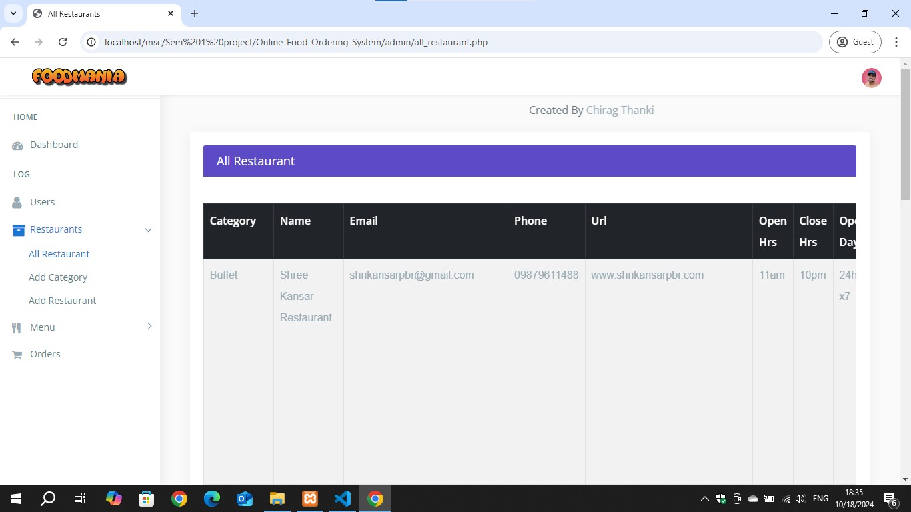

<!DOCTYPE html>

<html lang="en">

<?php

include("../connection/connect.php");

error_reporting(0);

session_start();

?>

<head>

    <meta charset="utf-8">

    <meta http-equiv="X-UA-Compatible" content="IE=edge">

    <meta name="viewport" content="width=device-width, initial-scale=1">

    <meta name="description" content="">

    <meta name="author" content="">

    <link rel="icon" type="image/png" sizes="16x16" href="images/favicon.png">

    <title>All Restaurants</title>

    <link href="css/lib/bootstrap/bootstrap.min.css" rel="stylesheet">

    <link href="css/helper.css" rel="stylesheet">

    <link href="css/style.css" rel="stylesheet">

</head>

<body class="fix-header fix-sidebar">

    <div class="preloader">

        <svg class="circular" viewBox="25 25 50 50">

            <circle class="path" cx="50" cy="50" r="20" fill="none" stroke-width="2" stroke-miterlimit="10" />

        </svg>

    </div>

    <div id="main-wrapper">

        <div class="header">

            <nav class="navbar top-navbar navbar-expand-md navbar-light">

                <div class="navbar-header">

                    <a class="navbar-brand" href="dashboard.php">

                        <span><img src="../images/food-mania-logo.png" alt="homepage" class="dark-logo" /></span>

                    </a>

                </div>

                <div class="navbar-collapse">

                    <ul class="navbar-nav mr-auto mt-md-0">

                    </ul>

                    <ul class="navbar-nav my-lg-0">

                        <li class="nav-item dropdown">

                            <div class="dropdown-menu dropdown-menu-right mailbox animated zoomIn">

                                <ul>

                                    <li>

                                        <div class="drop-title">Notifications</div>

                                    </li>

                                    <li>

                                        <a class="nav-link text-center" href="javascript:void(0);"> <strong>Check all

                                                notifications</strong> <i class="fa fa-angle-right"></i> </a>

                                    </li>

                                </ul>

                            </div>

                        </li>

                        <li class="nav-item dropdown">

                            <a class="nav-link dropdown-toggle text-muted  " href="#" data-toggle="dropdown"

                                aria-haspopup="true" aria-expanded="false"><img src="images/bookingSystem/user_icon.jpg"

                                    alt="user" class="profile-pic" /></a>

                            <div class="dropdown-menu dropdown-menu-right animated zoomIn">

                                <ul class="dropdown-user">

                                    <li><a href="logout.php"><i class="fa fa-power-off"></i> Logout</a></li>

                                </ul>

                            </div>

                        </li>

                    </ul>

                </div>

            </nav>

        </div>

        <div class="left-sidebar">

            <div class="scroll-sidebar">

                <nav class="sidebar-nav">

                    <ul id="sidebarnav">

                        <li class="nav-devider"></li>

                        <li class="nav-label">Home</li>

                        <li> <a href="dashboard.php"><i class="fa fa-tachometer"></i><span>Dashboard</span></a></li>

                        <li class="nav-label">Log</li>

                        <li> <a href="all_users.php"> <span><i

                                        class="fa fa-user f-s-20 "></i></span><span>Users</span></a></li>

                        <li> <a class="has-arrow  " href="#" aria-expanded="false"><i

                                    class="fa fa-archive f-s-20 color-warning"></i><span

                                    class="hide-menu">Restaurants</span></a>

                            <ul aria-expanded="false" class="collapse">

                                <li><a href="all_restaurant.php">All Restaurant</a></li>

                                <li><a href="add_category.php">Add Category</a></li>

                                <li><a href="add_restaurant.php">Add Restaurant</a></li>

                            </ul>

                        </li>

                        <li> <a class="has-arrow  " href="#" aria-expanded="false"><i class="fa fa-cutlery"

                                    aria-hidden="true"></i><span class="hide-menu">Menu</span></a>

                            <ul aria-expanded="false" class="collapse">

                                <li><a href="all_menu.php">All Menues</a></li>

                                <li><a href="add_menu.php">Add Menu</a></li>

                            </ul>

                        </li>

                        <li> <a href="all_orders.php"><i class="fa fa-shopping-cart" aria-hidden="true"></i><span>Orders</span></a></li>

                  </ul>

                </nav>

            </div>

        </div>

        <div class="page-wrapper">

            <div style="padding-top: 10px;">

                <marquee onMouseOver="this.stop()" onMouseOut="this.start()">Created By <a

                        href="https://chigs-thanky.github.io/Chirag-J-Thanki-Portfolio/">Chirag Thanki</a></marquee>

            </div>

            <div class="container-fluid">

                <div class="row">

                    <div class="col-12">

                        <div class="col-lg-12">

                            <div class="card card-outline-primary">

                                <div class="card-header">

                                    <h4 class="m-b-0 text-white">All Restaurant</h4>

                                </div>

                                <div class="table-responsive m-t-40">

                                    <table id="example23"

                                        class="display nowrap table table-hover table-striped table-bordered"

                                        cellspacing="0" width="100%">

                                        <thead class="thead-dark">

                                            <tr>

                                                <th>Category</th>

                                                <th>Name</th>

                                                <th>Email</th>

                                                <th>Phone</th>

                                                <th>Url</th>

                                                <th>Open Hrs</th>

                                                <th>Close Hrs</th>

                                                <th>Open Days</th>

                                                <th>Address</th>

                                                <th>Image</th>

                                                <th>Date</th>

                                                <th>Action</th>

                                            </tr>

                                        </thead>

                                        <tbody>

                                            <?php

                                            $sql = "SELECT * FROM restaurant order by rs_id desc";

                                            $query = mysqli_query($db, $sql);

                                            if (!mysqli_num_rows($query) > 0) {

                                                echo '<td colspan="11"><center>No Restaurants</center></td>';

                                            } else {

                                                while ($rows = mysqli_fetch_array($query)) {

                                                    $mql = "SELECT * FROM res_category where c_id='" . $rows['c_id'] . "'";

                                                    $res = mysqli_query($db, $mql);

                                                    $row = mysqli_fetch_array($res);

                                                    echo ' <tr><td>' . $row['c_name'] . '</td>

                                                                                                <td>' . $rows['title'] . '</td>

                                                                                                <td>' . $rows['email'] . '</td>

                                                                                                <td>' . $rows['phone'] . '</td>

                                                                                                <td>' . $rows['url'] . '</td>

<td>' . $rows['o_hr'] . '</td>

                                                                                                <td>' . $rows['c_hr'] . '</td>

                                                                                                <td>' . $rows['o_days'] . '</td>

<td>' . $rows['address'] . '</td>

<td><div class="col-md-3 col-lg-8 m-b-10">

                                                                                                <center><img src="Res_img/' . $rows['image'] . '" class="img-responsive radius"  style="min-width:150px;min-height:100px;"/></center>

                                                                                              </div></td>

<td>' . $rows['date'] . '</td>

                                                                                                     <td><a href="delete_restaurant.php?res_del=' . $rows['rs_id'] . '" class="btn btn-danger btn-flat btn-addon btn-xs m-b-10"><i class="fa fa-trash-o" style="font-size:16px"></i></a>

                                                                                                     <a href="update_restaurant.php?res_upd=' . $rows['rs_id'] . '" class="btn btn-info btn-flat btn-addon btn-sm m-b-10 m-l-5"><i class="fa fa-edit"></i></a>

                                                                                                    </td></tr>';

                                        </tbody>

                                    </table>

                                </div>

    <?php include "include/footer.php" ?>

    </div>

   </div>

</body>

</html>

Admin Managing All Users

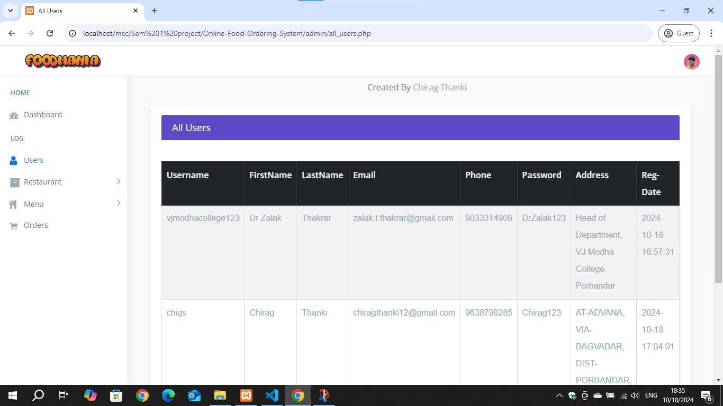

<!DOCTYPE html>

<html lang="en">

<?php

include("../connection/connect.php");

?>

<head>

    <meta charset="utf-8">

    <meta http-equiv="X-UA-Compatible" content="IE=edge">

    <meta name="viewport" content="width=device-width, initial-scale=1">

    <meta name="description" content="">

    <meta name="author" content="">

    <title>All Users</title>

    <link href="css/lib/bootstrap/bootstrap.min.css" rel="stylesheet">

    <link href="css/style.css" rel="stylesheet">

</head>

<body>

<div id="main-wrapper">

        <div class="header">

            <nav class="navbar top-navbar navbar-expand-md navbar-light">

                <div class="navbar-header">

                    <a class="navbar-brand" href="dashboard.php">

                        <span><img src="../images/food-mania-logo.png" alt="homepage" class="dark-logo" /></span>

                    </a>

                </div>

                <div class="navbar-collapse"> <li class="nav-item dropdown">

<a class="nav-link dropdown-toggle text-muted  " href="#" data-toggle="dropdown"

aria-haspopup="true" aria-expanded="false">

<img src="images/bookingSystem/user_icon.jpg"

                                    alt="user" class="profile-pic" /></a>

                            <div class="dropdown-menu dropdown-menu-right animated zoomIn">

                                <ul class="dropdown-user">

                                    <li><a href="logout.php"><i class="fa fa-power-off"></i> Logout</a></li>

                                </ul>

                            </div>

                        </li>

 <nav class="sidebar-nav">

                    <ul id="sidebarnav">

                        <li class="nav-devider"></li>

                        <li class="nav-label">Home</li>

                        <li> <a href="dashboard.php"><i class="fa fa-tachometer"></i><span>Dashboard</span></a></li>

                        <li class="nav-label">Log</li>

                        <li> <a href="all_users.php"> <span><i

                                        class="fa fa-user f-s-20 "></i></span><span>Users</span></a></li>

                        <li> <a class="has-arrow  " href="#" aria-expanded="false"><i

                                    class="fa fa-archive f-s-20 color-warning"></i><span

                                    class="hide-menu">Restaurant</span></a>

                            <ul aria-expanded="false" class="collapse">

                                <li><a href="all_restaurant.php">All Restaurants</a></li>

                                <li><a href="add_category.php">Add Category</a></li>

                                <li><a href="add_restaurant.php">Add Restaurant</a></li>

                            </ul>

                        </li>

<div class="page-wrapper">

            <div style="padding-top: 10px;">

                <marquee onMouseOver="this.stop()" onMouseOut="this.start()">Created By <a

                        href="https://chigs-thanky.github.io/Chirag-J-Thanki-Portfolio/">Chirag Thanki</a></marquee>

            </div>

<div class="table-responsive m-t-40">

                                    <table id="myTable" class="table table-bordered table-striped table-hover">

                                        <thead class="thead-dark">

                                            <tr>

                                                <th>Username</th>

                                                <th>FirstName</th>

                                                <th>LastName</th>

                                                <th>Email</th>

                                                <th>Phone</th>

                                                <th>Password</th>

                                                <th>Address</th>

                                                <th>Reg-Date</th>

                                                <th>Action</th>

                                            </tr>

                                        </thead>

                                        <tbody>

                                            <?php

                                            $sql = "SELECT * FROM users order by u_id desc";

                                            $query = mysqli_query($db, $sql);

                                            if (!mysqli_num_rows($query) > 0) {

                                                echo '<td colspan="7"><center>No Users</center></td>';

                                            } else {

                                                while ($rows = mysqli_fetch_array($query)) {

                                                    echo ' <tr><td>' . $rows['username'] . '</td>

                                                                                                <td>' . $rows['f_name'] . '</td>

                                                                                                <td>' . $rows['l_name'] . '</td>

                                                                                                <td>' . $rows['email'] . '</td>

                                                                                                <td>' . $rows['phone'] . '</td>

                                                                                                <td>' . $rows['password'] . '</td>

                                                                                                <td>' . $rows['address'] . '</td>

                                                                                                <td>' . $rows['date'] . '</td>

                                                                                                     <td><a href="delete_users.php?user_del=' . $rows['u_id'] . '" class="btn btn-danger btn-flat btn-addon btn-xs m-b-10"><i class="fa fa-trash-o" style="font-size:16px"></i></a>

                                                                                                     <a href="update_users.php?user_upd=' . $rows['u_id'] . '" " class="btn btn-info btn-flat btn-addon btn-sm m-b-10 m-l-5"><i class="fa fa-edit"></td></tr>';

                     }

                      }

                       ?>

                   </tbody>

                 </table>

              </div>

<?php include "include/footer.php" ?>

</div>

</body>

</html>

5.2 User Layout

User side HOME pages

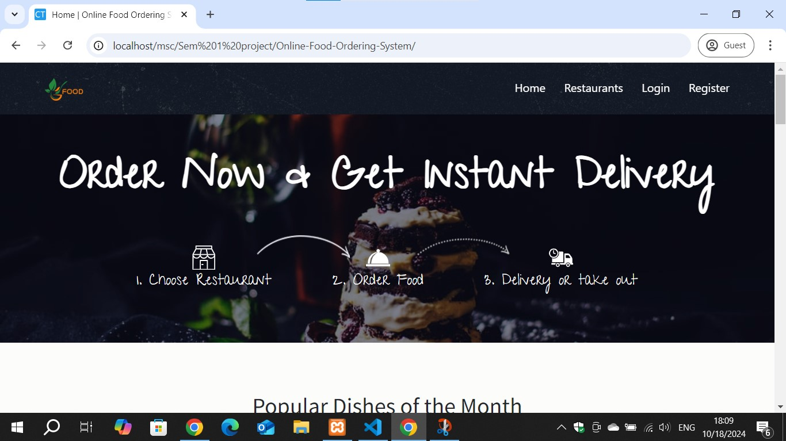

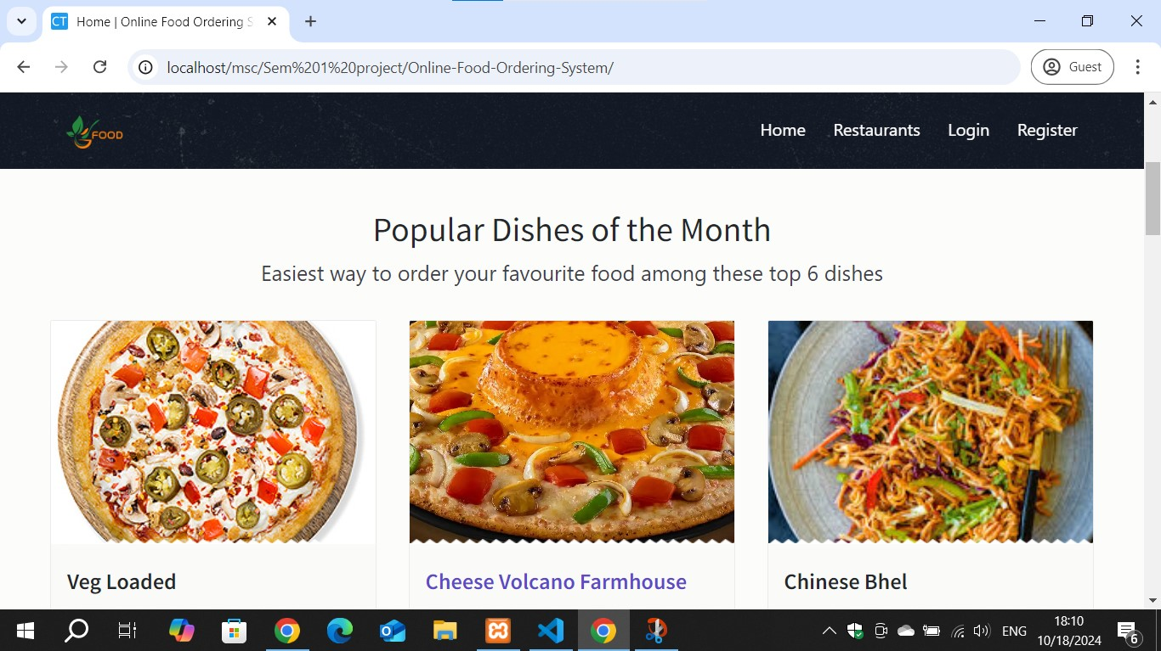

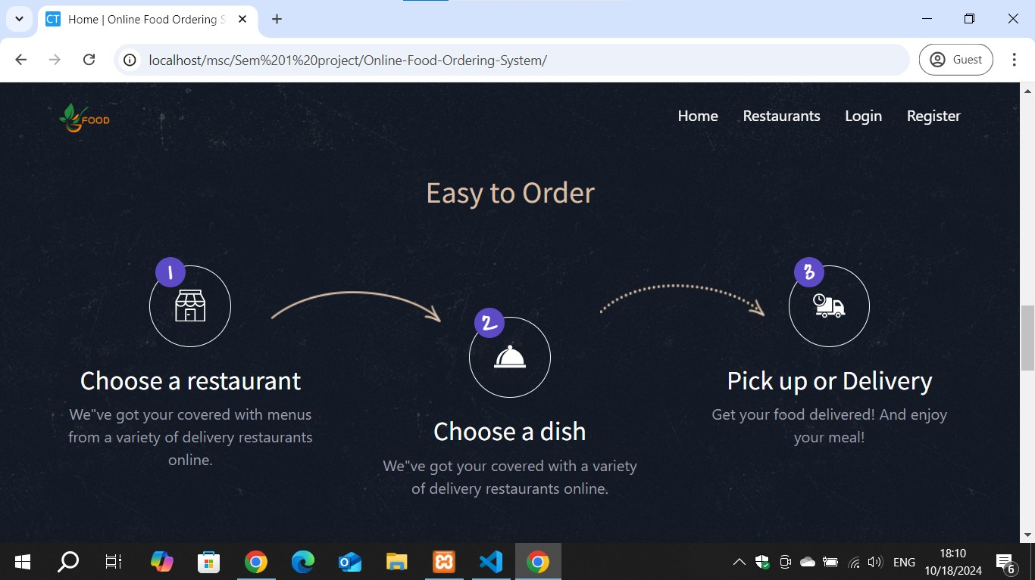

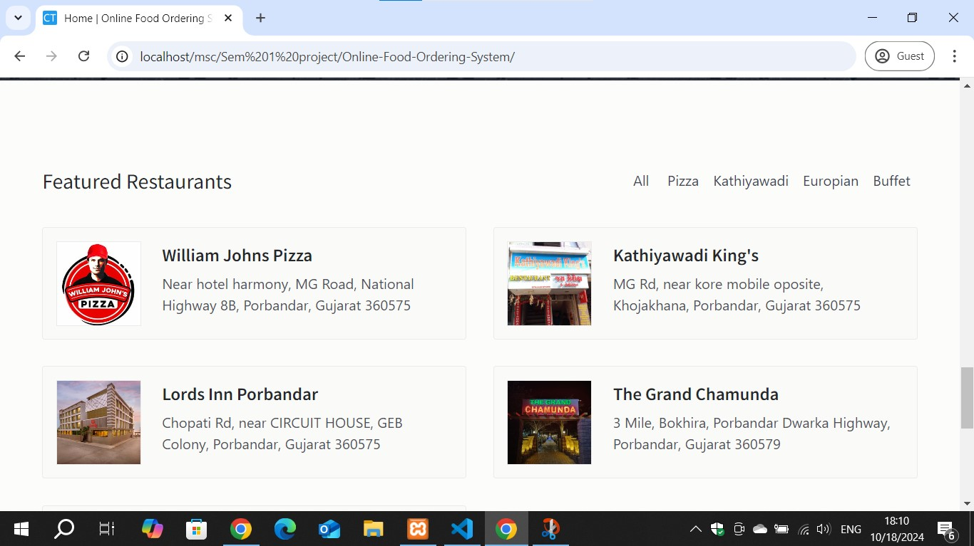

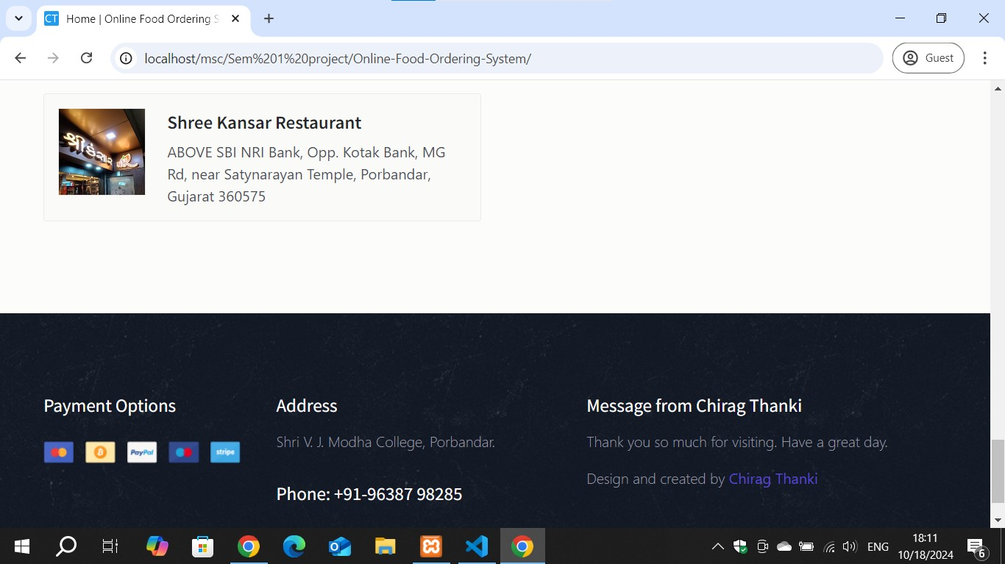

<!--  Author Name: Chirag Thanki

                        GigHub Link: https://github.com/chigs-thanky

                        Contact: +91-9638798285

                        Email: chiragthanki12@gmail.com-->

<!DOCTYPE html>

<html lang="en">

<?php

include("connection/connect.php");

error_reporting(0);

session_start();

?>

<head>

    <meta charset="utf-8">

    <meta http-equiv="X-UA-Compatible" content="IE=edge">

    <meta name="viewport" content="width=device-width, initial-scale=1, shrink-to-fit=no">

    <meta name="description" content="">

    <meta name="author" content="">

    <link rel="icon" href="./images/favicon.ico">

    <title>Home | Online Food Ordering System - By Chirag Thanki</title>

    <link href="css/bootstrap.min.css" rel="stylesheet">

    <link href="css/font-awesome.min.css" rel="stylesheet">

    <link href="css/animsition.min.css" rel="stylesheet">

    <link href="css/animate.css" rel="stylesheet">

    <link href="css/style.css" rel="stylesheet">

</head>

<body class="home">

<section class="hero bg-image" data-image-src="images/img/pimg.jpg">

        <div class="hero-inner">

            <div class="container text-center hero-text font-white">

                <h1>Order Now & Get Instant Delivery </h1>

 <h4><span style="color:white;">1. </span>Choose Restaurant</h4>

                    </div>

                    <div class="step-item step2">

                        <svg xmlns="http://www.w3.org/2000/svg" width="512" height="512" viewbox="0 0 380.721 380.721"></svg>

                        <h4><span style="color:white;">2. </span>Order Food</h4>

                    </div>

                    <div class="step-item step3"

                        </svg>

                        <h4><span style="color:white;">3. </span>Delivery or take out</h4>

                    </div>

                </div>

                <div class="banner-form">

                    <form class="form-inline">

                    </form>

         </div>

        </div>

    </section>

    <?php include "include/footer.php" ?>

</body>

</html>

User Registration

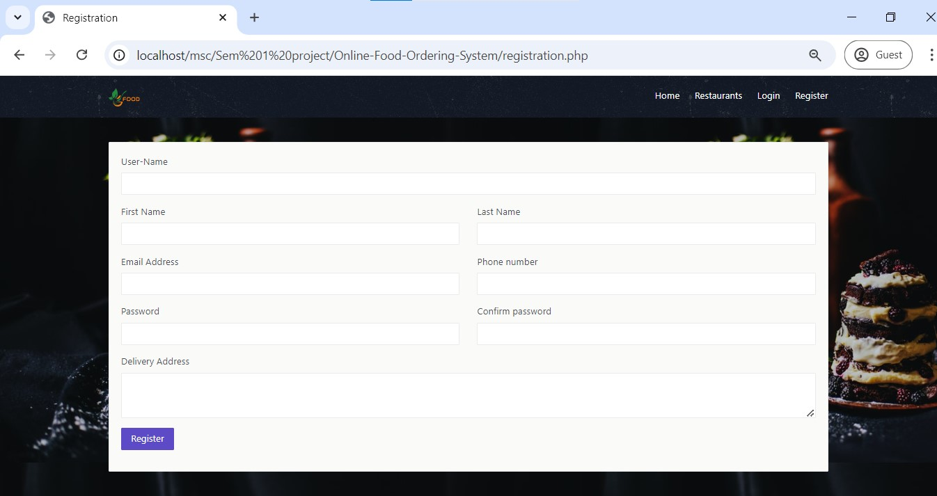

**Description:** User can register himself/herself if he/she is not already a user. After successful registration, they can login to place order of their favorite food.

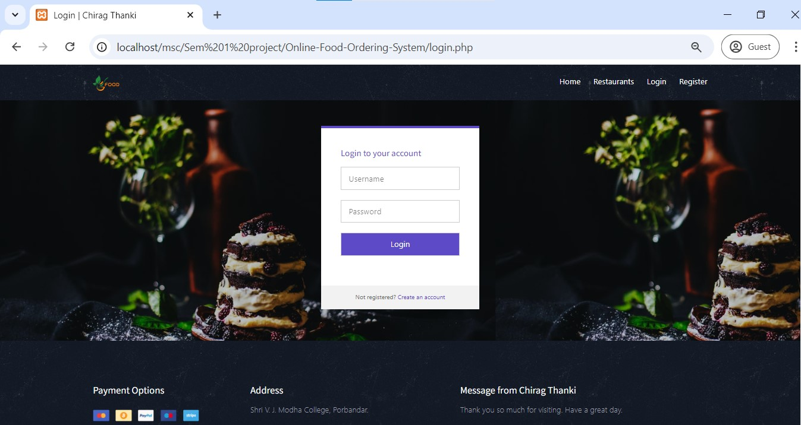

**Description:** After successfully login, they can see the page as shown below:

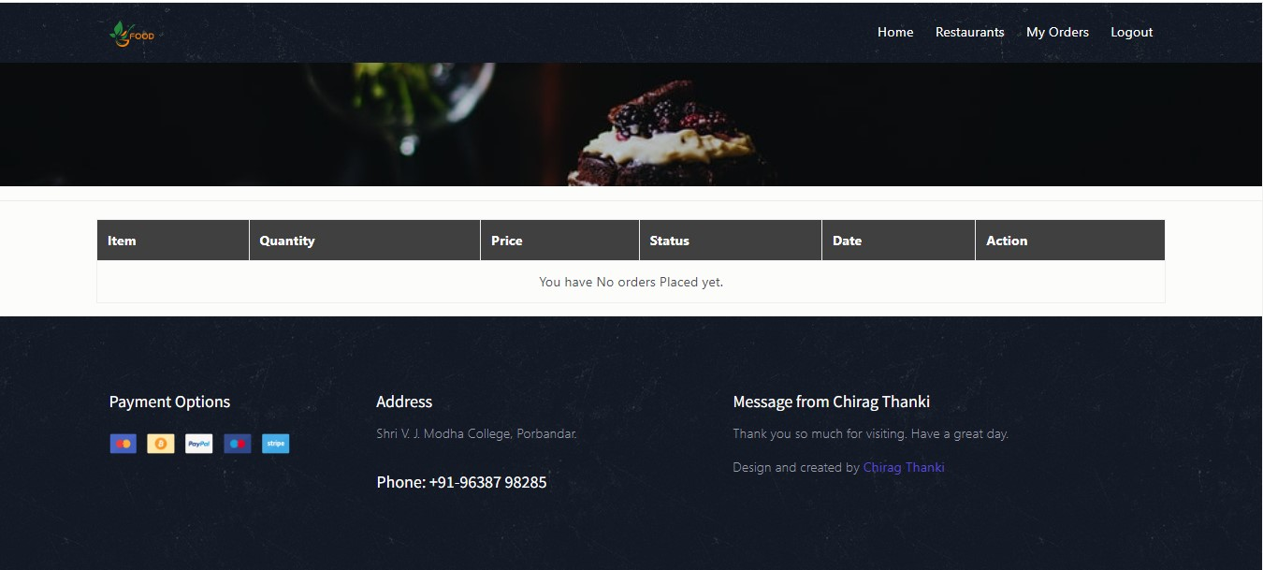

* As you can see, the user have not placed any order yet. If order has placed, it should display here and user can see that.

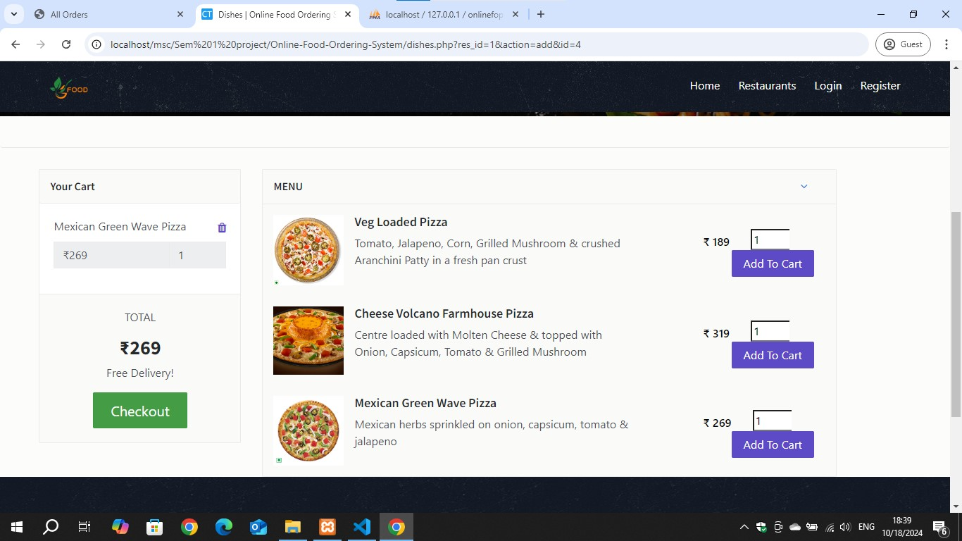

Description: As you can see, user can place order for different dishes he/she likes to eat. It is very easy to place order.

Chapter - 6 LIMITATIONS AND FUTURE ENHANCEMENTS

6.1 Limitations

6.2 Future Enhancements

6.1 Limitations

### **1. Dependence on Internet Connectivity**

* Users require stable internet access to place and track orders, which can be a barrier in areas with poor connectivity or for users without regular access to the internet.

### 2. **Service Area Limitations**

* Many systems are limited to specific geographic areas or cities, restricting access to people outside the delivery zones.

### 3. **Technical Issues**

* Downtime, bugs, and system crashes can lead to lost orders, frustrated users, or missed business opportunities for restaurants.

### 4. **Limited Personal Interaction**

* The lack of direct customer-to-server interaction can sometimes cause communication errors, especially for specific customizations or special requests.

### 5. **Payment Security Concerns**

* Despite encryption and security measures, some users may be concerned about sharing payment information online, which can deter them from using the platform.

### 6. **Delivery Delays**

* Although systems often provide estimated delivery times, unforeseen delays such as traffic, weather, or high order volume can still affect the service quality.

### 7. **High Service Fees**

* Some platforms charge high service fees or delivery costs, which can deter customers from using the service regularly. This also impacts restaurant profitability, as third-party delivery platforms take a cut.

### 8. **Data Privacy Issues**

* Customer data is collected, including payment details, addresses, and order histories, raising concerns about privacy and the potential misuse of personal information.

### 9. **Complex Menu Representation**

* It can be difficult for online platforms to represent the complexity of certain menus, especially for high-end or specialty restaurants where the experience of dining in-person is important.

### 10. **Restaurant Dependency on Platform**

* Many restaurants rely heavily on online platforms for orders, meaning they may lose a significant portion of their customer base if the platform experiences issues or decides to remove them.

### 11. **Errors in Orders**

* Miscommunication between the system and the restaurant staff can result in incorrect orders, leading to customer dissatisfaction.

### 12. **Limited Access for Technologically Unsavvy Users**

* Elderly or non-tech-savvy individuals may find it challenging to navigate and use an online food ordering platform.

### 13. **Environmental Impact of Delivery**

* Frequent use of online food ordering systems contributes to environmental concerns, such as excessive packaging waste and carbon emissions from delivery vehicles.

### 14. **Quality of Food on Arrival**

* The quality of food may degrade during delivery, affecting freshness and temperature, which can harm the overall customer experience.

6.2 Future Enhancements

### **1. Real-Time Order Tracking with GPS**

* Improve real-time tracking by integrating live GPS data, so customers can see the exact location of their delivery and get more accurate delivery times.

### **2. Dynamic Pricing & Surge Handling**

* Implement dynamic pricing based on demand and supply, such as lower delivery fees during non-peak hours, helping to balance demand and reduce wait times during rush hours.

### **3. Eco-Friendly Delivery Options**

* Introduce environmentally conscious options like bicycle delivery or electric vehicle deliveries to minimize the carbon footprint of deliveries.

### **4. Smart Kitchen Integration**

* Integrate the ordering system directly with smart kitchen equipment to streamline order preparation times and improve order accuracy.

### **5. Multi-Language Support**

* Add support for multiple languages and dialects, improving the system’s accessibility for non-English speakers or users in various regions.

### **6. Drone or Autonomous Delivery**

* Explore the use of drones or autonomous vehicles for faster, more efficient deliveries, reducing human dependency and cutting delivery times significantly.

### **7. Nutritional Information and Filters**

* Add detailed nutritional information for each dish and allow users to filter by specific criteria (e.g., calorie count, protein content) to support health-conscious ordering.

### **8. Offline Ordering Capabilities**

* Develop features that allow users to browse menus, add items to their cart, and place orders even with intermittent internet access, processing the order once the connection is restored.

Chapter - 7 CONCLUSION

7.1 Conclusion

7.2 Advantages

7.1 Conclusion

* In conclusion, the Online Food Services System project developed in PHP using MySQL database and using front-end (client-side) programming languages like HTML, CSS, JavaScript and frameworks like BootStrap, Laravel provides an efficient solution for managing orders and users for better services.
* The use of programming languages ensures platform independence and robust performance, while Visual Studio Code offers a user-friendly development environment.

7.2 Advantages

* Orders can be placed easily
* Payments can be made online in single tap
* Explore different food dishes with variety
* Prices of food dishes are transparent
* User can get discounts on sale or other offers
* Helps economy to boost by providing employment

Chapter - 8 BIBLIOGRAPHY

8.1 Bibliography

8.1 Bibliography

* Started with the Design of the Home page.
* Add required details like food dishes, restaurants & food prices.
* Make user login and registration for new users.
* Make admin login page.
* Make admin control page.
* Connect all pages to database.
* Write a back-end code for the admin side.
* Write a back-end code to logout.

Chapter - 9 REFERENCES

9.1 References

* I am thankful to my guide **Dr. Zalak Thakrar** for guiding me. I am also thankful to whole staff of the Computer Department for giving me huge support for my project.

**Sites:**

* www.google.com
* www.youtube.com
* www.stackoverflow.com

Thank You